Midterm Lab Task Set 1

Python Basic Input-Output/Operators/Escape Sequence

And Placeholders

Problem 1. Using print statement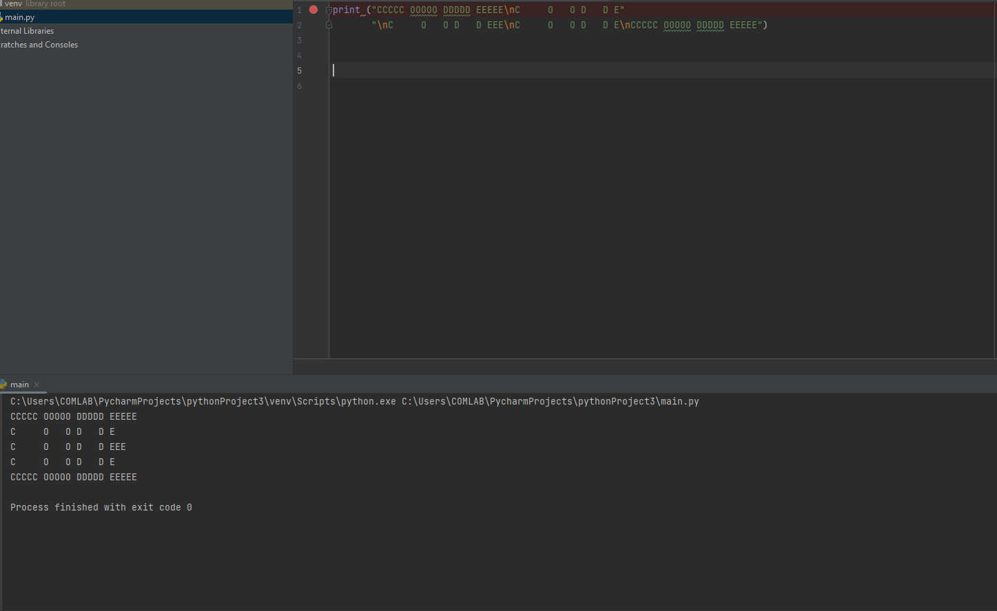

Problem 2. Using Escape Sequence. Use only 1 print statement for this output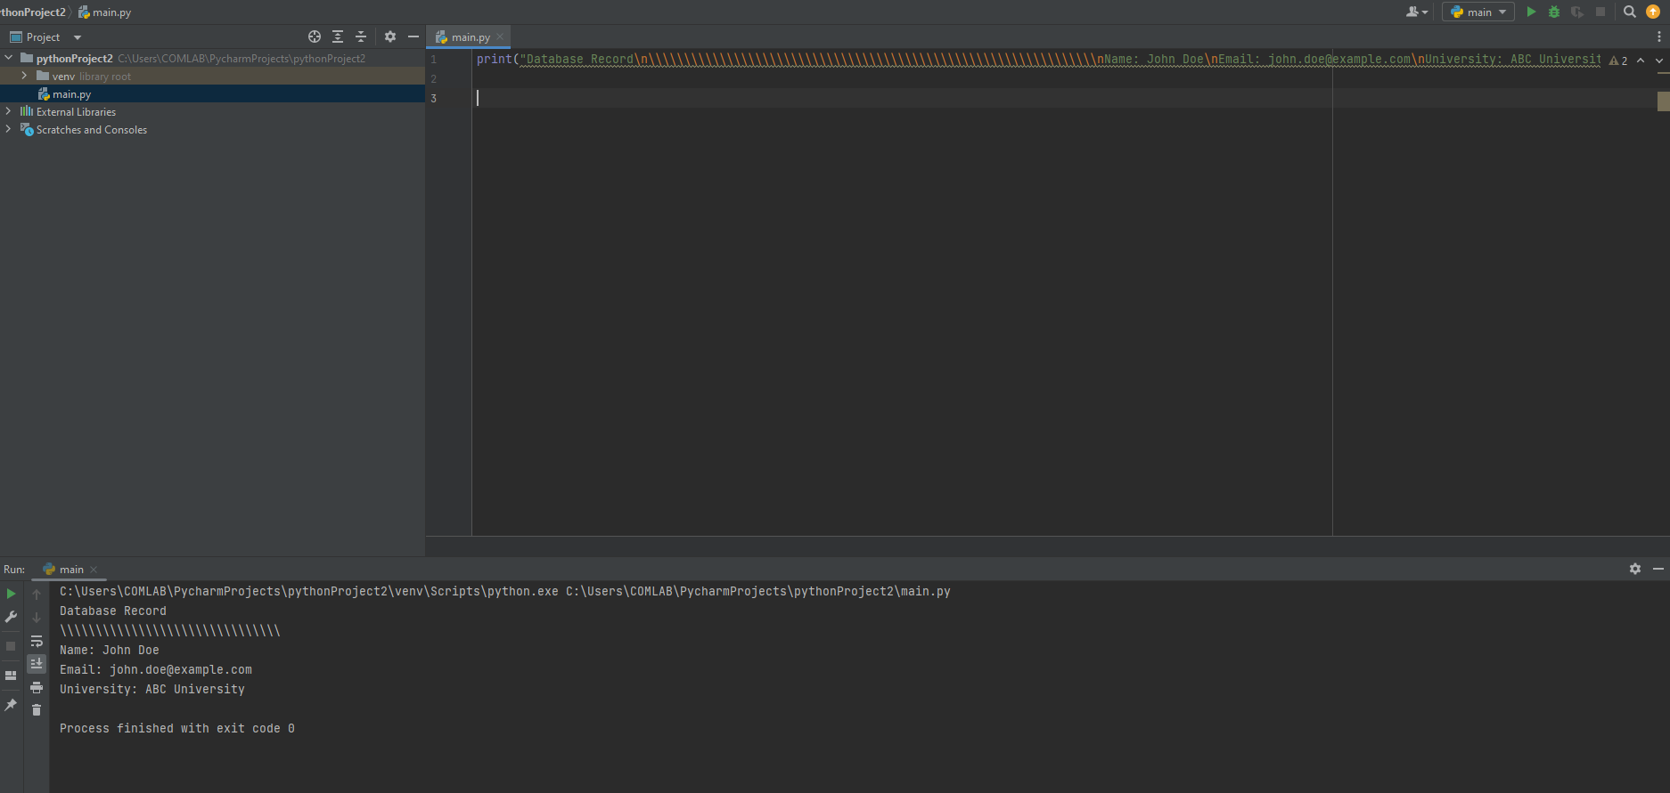

Problem 3. Input Operations

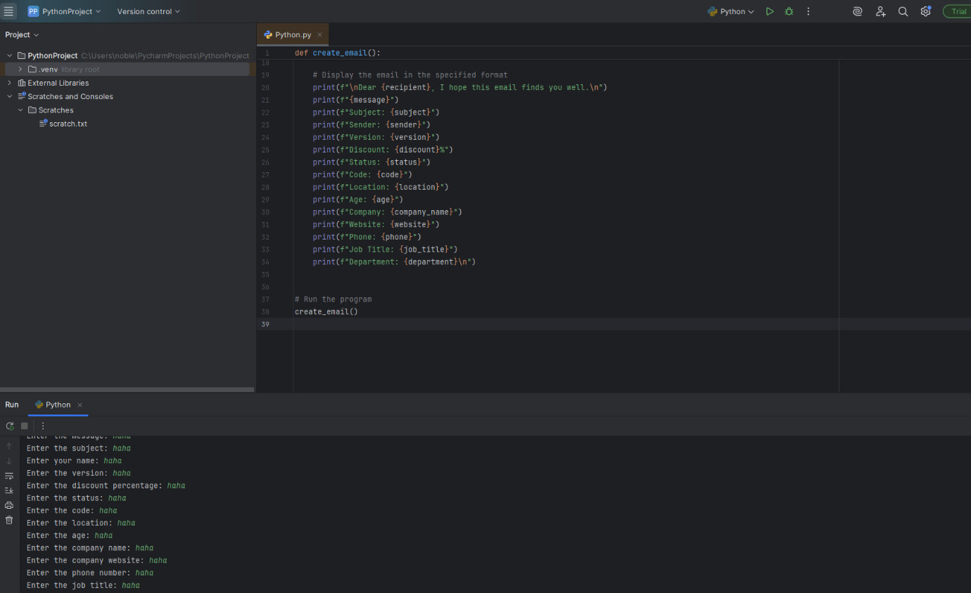

Problem 4. Using Placeholders with % specifier

S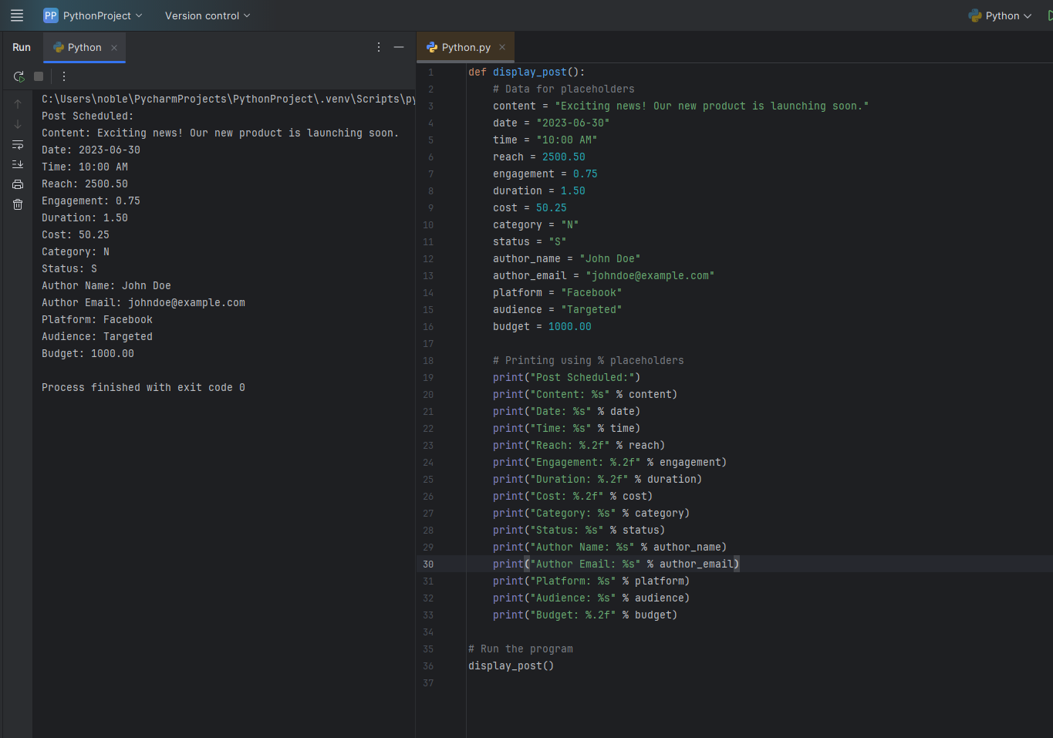

Problem 5. Type Casting

